**Ant Installation:**

1. Connect to your Jenkins instance and execute following commands to install ant

cd /opt

(<https://archive.apache.org/dist/ant/binaries/>)

wget http://apache.mirrors.tds.net/ant/binaries/apache-ant-1.10.9-bin.tar.gz

tar -xvzf apache-ant-1.10.9-bin.tar.gz

ls

cd apache-ant-1.10.9

pwd

/opt/apache-ant-1.10.9 ----🡪 this is the ant home path

export ANT_HOME=/opt/apache-ant-1.10.9

export PATH=$PATH:$ANT_HOME/bin

ant -version

================================================================================

**Ant – Jenkins Integration:**

1. Set env variable for ant

Global Tool configuration-> Ant

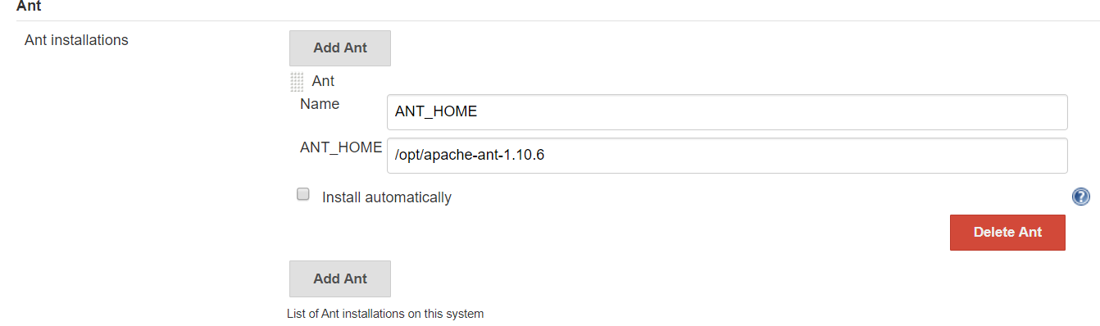

1. Create a **FreeStyle** **Job**.

SRC: <https://github.com/prakashk0301/Ant-WebProject>

Build: Invoke ant

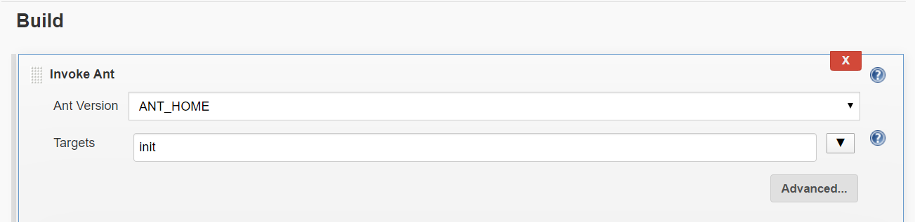

1. Build jenkins jobs

Jenkins will generate a deployable artifact.

Done 😊

==========================================================================

**How to Generate Jenkinfile for Ant: for Pipeline jobs**

1. Create a Pipeline Job for Ant.
2. Select withAnt from pipeline syntax generator.

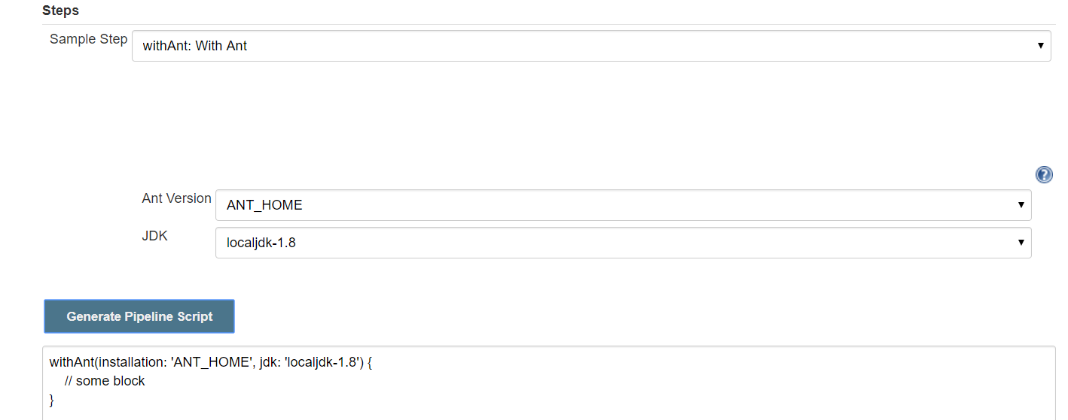

1. Create a Jenkinsfile in github project, and add a stage to build using ant.

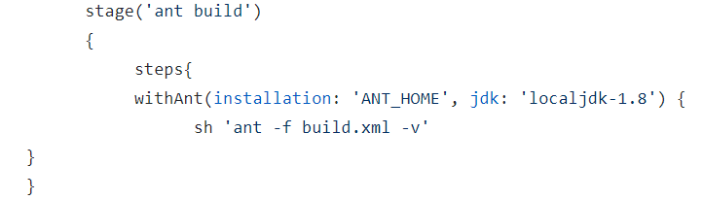

Build your job, Done.

Reference jenkinsfile for ant:

<https://github.com/prakashk0301/Ant-WebProject/blob/pipeline/Jenkinsfile>